Banking: spending/saving/bill tracking

|  |  |  |  |  |  |
| --- | --- | --- | --- | --- | --- |
| |  |  |  |  |  | | --- | --- | --- | --- | --- | | Dharmay Sureja  B00904061 | Sagarkumar Vaghasia  B00878629 | Radhey Rupapara  B00910695 | Jayshree Ramasubramanian  B00894948 | Tejaswini Rallapalli  B00888478 |   UX Design Report |

**Abstract**

Money management could be a tedious task when it comes to manually write it down each spending we made or remembering when to pay out bills monthly. Thus, mobile-based financial management applications impact users with various literacy rates, and the user interface of the application impact the learnability of the user and avoid conventional ways to manage money [2,3]. For users, the design or the interface of the application matters when it comes to the learnability of the application. This impacts users to shift to the app-based system rather than traditional money management strategies. Learnability may again vary between different users and the impact of digital finances and budget planning has bought a change in how people spend and save money for the future. One of the patterns which are getting the user’s attention these days is by use of mobile apps that will allow users to manage finances digitally, get timely reminders before the bill due dates, create budget plans for future savings or a hassle-free way to calculate interest for the loans. So, we have developed an application on “spending/saving/bill tracking using mobile apps” which will allow users to make budget plans, set reminders for bill due payments, and get the analysis of their spending by increasing the user experience on the existing applications and provide learnability for users of various literacy rates.

To build and develop this application we have gone through “Contextual Inquiry” first which acted as a requirement-gathering phase and secondly, we performed a “Cognitive Walkthrough” study to understand the opinions of the user and observations when they use this application. By performing these two tasks, we observed what features users generally like or dislike, what features they use to perform tasks and what way users prefer to use the application. This paper contains the studies that we performed and the observations along with the feedback that users gave to us and the application design.

**Keywords**

Money Management; Bill tracking; expenditure analysis; visualization

**Introduction**

Banking has become a part of everyone’s life and money management could be tedious be it from paying bills, analyzing our spending, etc. Our research focuses on creating money management applications and finding shortcomings of existing applications that can help in analyzing spending, bill tracking, and savings. When we physically record every purchase, we have to remember when to make monthly bill payments and manage money, which is a difficult chore to do regularly. Our study focuses on the various money management apps and how to design applications in such a way that users can benefit from them to manage their finances, get expenditure analysis, and keep track of their expenses. This study also focuses on features of computing interest for loan installments and sending users timely reminders to make their payments. Finding the design implications with currently available applications and improving and creating a better usable design is the key goal of this work. The process of identifying issues with current applications to designing prototypes is done by conducting studies followed by a series of observations and question-answer sessions. Wireframes are to be designed using the results from studies like contextual inquiry and then a cognitive walkthrough will be performed to find out about design issues with prototypes and severity with respect to a predefined user persona of Abby.

**Background and Problem Statement**

As people around the world are experiencing the effect of growing inflation every day, they feel less and less motivated in saving for their future or big dreams. Therefore, management of finance and accounts has been a critical issue for a long time; still, in recent decades, it has gotten a new perspective with the advent of modern technologies and the internet which is becoming more and more accessible. It presents a new challenge for designers and developers in terms of digital products which will help people to track and manage their money flows.

Nowadays, banking has become an integral part of everyone’s life and money management could be tedious in terms of paying bills, analyzing our spending, etc[5]. People in old days either memorize the important dates or write it down on sticky notes. But nowadays, they do not have enough time and effort to write down everything on paper[3]. Also, when they used to analyze or summarize the transactions monthly then it became tough for users to comprehend the expenses and visualize their expenditures and income. Due to the exorbitant use of resources and work stress, people do not have enough amount of time to analyze their expenditures and income, pay bills on the due date or comprehend some basic calculations. Our research focuses on creating money management applications and finding shortcomings of existing applications which can help in analyzing spending, bill tracking, savings, and saving interest amounts on loans by estimating the loan tenure if the installment amount can be increased.

Many times people have due dates of different bill payments on different days such as credit bill card payment date, home rental payment date, car loan installment payment date, mobile bill payment date, etc. So, they do not remember each, and every date and they need either someone to remember them or write it down. This process is time-consuming or hectic and this gives stress. In addition to that sometimes people forget some of the due dates for the bill payment. To optimize the time and efforts of the user, we provide them more flexibility we developed a “Banking: spending/saving/bill tracking” application. Here, users can set reminders for their bill payments. They can easily create reminders according to their needs and set the frequency of the reminder and the notification time also to remind them. After setting reminders they can easily view them and edit or delete them.

Sometimes user wants to analyze their expenditure. Using the traditional methods for analyzing expenditures and income will take too much time and a lot of burdens too. We have also developed a feature that will allow users to visualize their spending in terms of categories, monthly spending, the trend of their spending and also the spending in the interval of time. In the end, what matters is the accessibility of the application. There are other applications also available in the market. Then, we came up with the question that why any user will use our application. The answer to this question is that available applications in the market have many flaws and there are only limited features available in those applications. But in our application, we have increased the capabilities by extending features to another level and integrating different features in a single application.

A lot of people across the globe are owing loans from either banks or financial institutions. In this scenario, consider a user for whom if the salary is increased or decreased then the user will have to consult the bank or institution for getting a new quotation or estimation. In this scenario, it will become time consuming and tedious task for the user. Our loan calculator feature will allow users to get insights into the updated loan installment when they input the required fields for the loan calculator. This feature will also give access to the user to enter the desired amount of previous loan installments amount, rate of interest, principal amount, loan tenure, and many more. By using this feature, the user will be able to predict the amount of interest saved on the loan and also get predictions about how early the user can pay off the loan amount. Furthermore, all the solutions to the features and the problems which we have discussed in this section are elaborated on in the next sections.

**Learning about YNAB**

To learn more about the application, we made a study in which different users ran through the application, and we studied their behavior and how they were using the application if they faced any problems or found any difficulty in using the application. We noted their behavior, asked them several questions and wrote the reviews. We created an Affinity Diagram from this data, separated the observations according to their similarities, and grouped them. From this observation, we got other ideas to develop the prototypes. This method is Contextual Inquiry.

**Contextual Inquiry Process**

When we manually record every purchase we make or have to remember when to make monthly bill payments, managing our money can be a tedious task. Our study focused on the different money management apps and how users can use them to manage their finances, get spending analysis, and keep track of their expenses. This study also focused on computing interest for loan installments and sending users timely reminders to pay their payments. The key goals of this study were to find the need for using these applications and identify the shortcomings of the already available money management applications on the market.

In this study, we outlined several factors that consumers should consider while managing their finances rather than keeping track of bill due dates or writing down every expense. To conduct this study, we observed users working on tasks using the existing program and posed various questions to them. Before interviewing users to complete specific activities based on the features, we first analyzed the application and identified the features that these applications possessed. To fully understand what users desire and what needs to be changed in the application, we also asked users a few post-study interview questions on various topics.

Focusing on user experience and user interface, which significantly impact how well an application is used, is another important goal of this study. By conducting user interviews, we were able to identify the areas in which users are most likely to focus while using the application and pay attention to those areas where consumers believe there is room for improvement. We updated the application standards after receiving user input so that users may manage bill payments and expenses and receive notifications before due dates. The ultimate purpose of this study was to satisfy the needs of this user and give them a novel financial management experience by eschewing conventional methods.

In this study, we called three users to test the already existing application YNAB[8]. We have selected four tasks that users performed; they were:

* Setting reminders for bill payments
* Performing expenditure analysis
* Budgeting that helps save money as users can track their expenditure
* Estimating savings on the interest of loans through the application.

We explained to the user about the features and asked them to perform those features on the YNAB application. While they were performing the task in the application, we wrote the observations for all the tasks they performed. After they performed each task, we asked them to answer a few questions related to the tasks. At the end of each study, we had a short interview to learn more about the user’s overall experience using the application and the application in general. We also asked them about their approach used to perform tasks.

Using this study, we understood user needs as we found out the users’ needs through the studies. As we knew the user’s expectations and feedback, we knew which parts needed to be improved.

After getting all the essential information from reviews and suggestions from the interviewers, we noticed that most of the information collected was qualitative data. Thus, to understand the problems correctly, we started building Affinity Diagrams.

The Affinity diagram groups numerous concepts into their logical relationships. It is the result of a brainstorming session that we had planned [7].

In this process, our team members split the interviewer’s suggestions and reviews and wrote all the points on sticky notes. One after another, all the members stacked their respective notes on the workbench. Whenever a user adds a sticky note, he checks whether the note they try to add fits with any other group member’s notes. If it didn’t match with anyone, then we stuck notes in an empty place. Doing this, the first round was almost completed.

Now, after we grouped the items as we thought of them as an individual. We discussed with our group, took everyone’s suggestions, moved the notes to different groups as needed and even created some new groups. Doing this, the second round was completed.

For the third round, we started giving names to each to each group that was formed and made it all a different theme.

These gave us ideas of what improvements were needed. After doing this study, we had a clear idea of what improvement was needed, and we started working on developing the new prototypes keeping the suggestions and improvements in mind.

**Results and Discussion**

After we conducted the interview, the following were the results as per the tasks:

1. **Setting reminders for bill payments**

While performing this task, we noticed that users were finding it difficult to use the app as they were confused about finding the “Add reminder” button. But after a bit of struggle, they managed to create a reminder for payment. Users liked the dark theme of the application, but the interface was not intuitive, and because of this, it took a while as they were expecting a “add reminder” button. There was also no option for multiple credit card payments reminder. The user also suggested giving colors to different reminders to separate them according to the dates. They also suggested having an icon of date for the reminder on the home screen and an edit menu. Users said that giving some tutorials to use features would be a great help.

1. **Performing expenditure analysis**

Users were exploring the analysis of the expenditure in which they felt confused when they were asked to add a bank account first. They suggested they could see the analysis, even without the graphs, for the manually entered details. Overall, the user liked the interface of the feature, and the navigation bar looked intuitive because the icon logos were good-looking. They need help to modify the expenses as they need lots of clicks. Users suggested having a back button in the steps that help them to go to the recent pages. They suggested multiple graphs according to the timespan, such as a month, week, or year so that users can analyze the expense adequately. We also found that users used the traditional way to write and track their expenses previously, and usage of an application would greatly help them.

1. **Budgeting that helps save money as users can track their expenditure**

Users found this feature attractive. They tried to use the feature by creating a budget and started assigning different amounts according to the categories of expenses. They also found the reminder option interesting, which sends a reminder whenever the user exceeds the expense limit, they set for the individual category. They also liked that the feature can be linked with a bank account so that they don’t need to enter the details of bank transactions every time. They suggested having a tutorial video or a summary for this feature as it is a bit complex and confusing for the new application users to understand.

1. **Estimating savings on the interest of loans through the application.**

The user found this feature very easy to use as it was intuitive and appreciated. They successfully set the categories, added amounts, and checked the change in interest amount they could save from loans. They said that the feature had easy to edit and change the budget. They just needed to edit the amount they could pay per installment; the role calculator did all the other calculations, and they found the result. Previously, users contacted the bank manager when they wanted to increase the installment amount.

After interviewing all the users, we wrote all observations on the sticky notes, grouped them based on their themes, and started working on Affinity Diagram.

For the first step, all the group members just stuck the notes as they thought, and the result looked below after we all got the notes on the board.

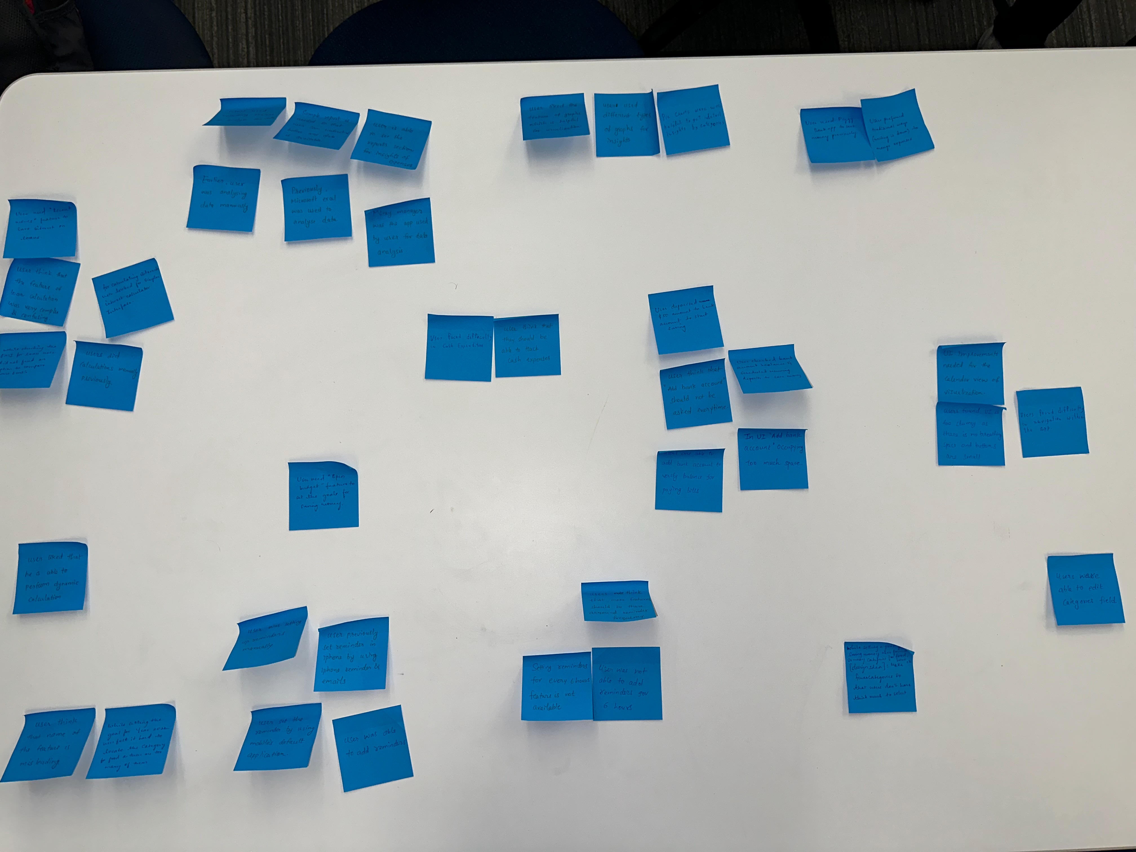

Figure 1 Affinity Diagram (Round 1)

The notes on the board we got could have been better in the group. Then we discussed with the group and then rearranged the notes according to everyone’s suggestion, and hence we also cleared out doubts from our group about the groups. The result of these looked as below.

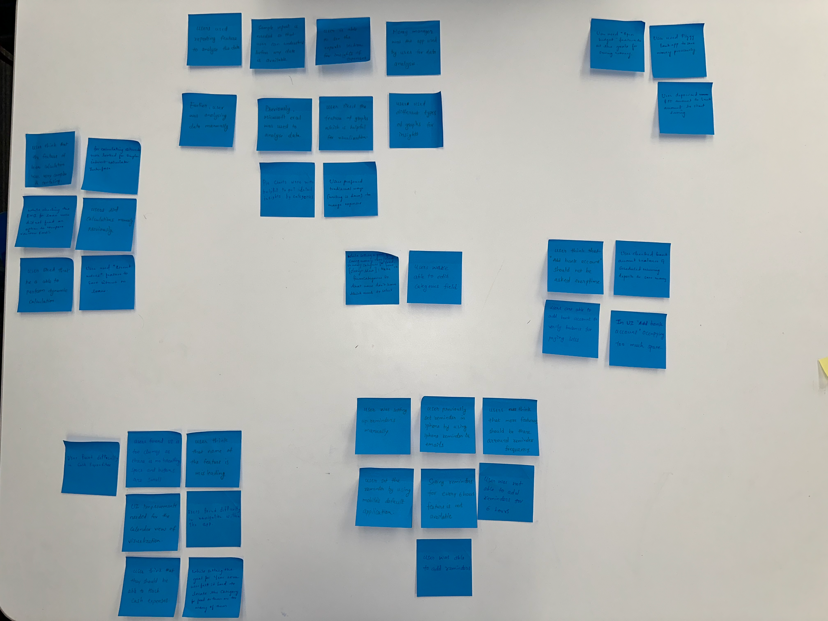

Figure 2 Affinity Diagram (Round 2)

After arranging the notes appropriately in the group, we discussed the description for each group formed in the above image. After brainstorming for the name of the description, we came to some names, which can be seen in the image below.

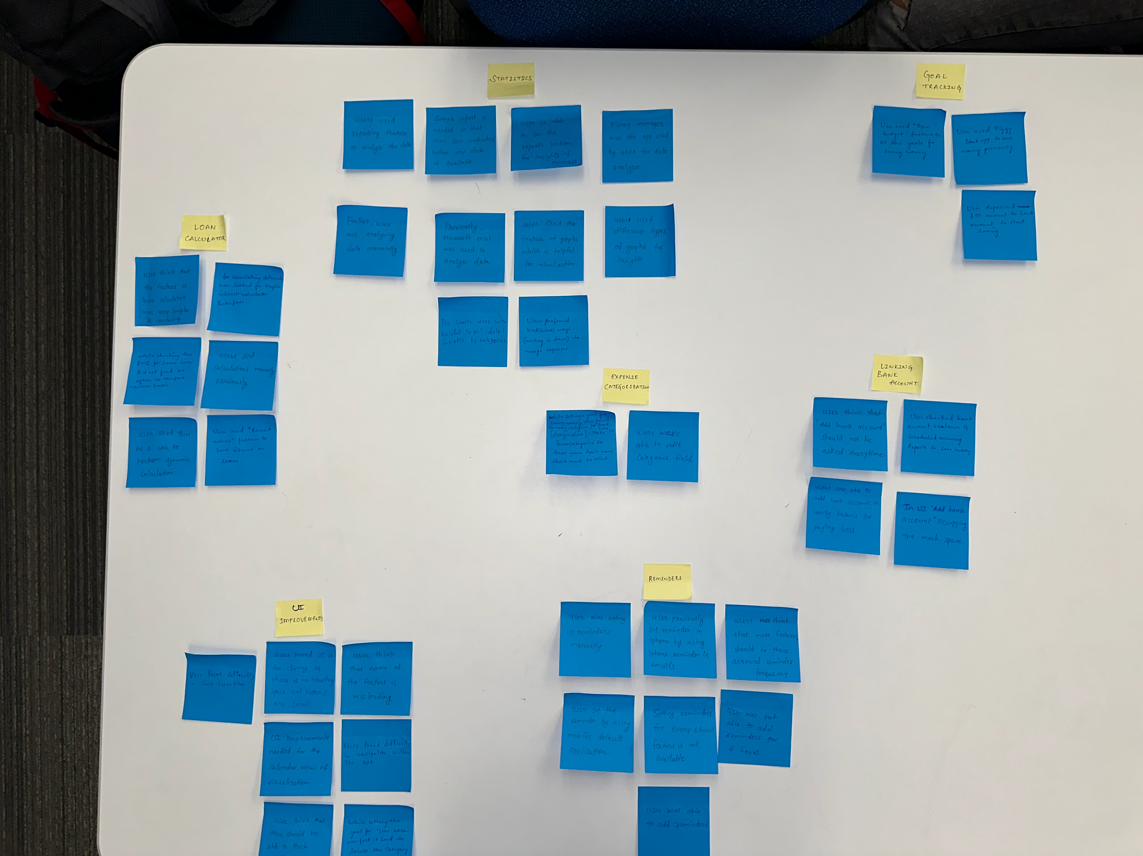

Figure 3 Affinity Diagram (Round 3)

We made seven themes by similar grouping notes. The themes were:

* Statistics
* Loan Calculator
* Reminders
* Goal Tracking
* Linking Bank Accounts
* Expense Categorization
* UI improvements

**Design Process**

Through the affinity diagram, we got to know that there were three major features that can be improved and applied in our application. These three features are setting reminders for custom time intervals, analyzing the data of expenditure using graphs, and predicting for early loan payoff for interest saving. The reason for selecting these features is that users were finding it difficult to do these tasks in the existing applications. Some users found it confusing to set reminders. Currently, the customized frequency of setting reminders with an interval was not supported. So, we decided to add Customized interval frequency for reminders to remind users multiple times to perform a specific transaction (Bill payment, loan payment, etc.) With the use of improved reminders, users will be notified more frequently according to their pace, which will result in fewer chances of missing a payment or a transaction. Also, only two types of graphs were available, which provides limited insights for analysis. Users suggested adding more graphs should be presented for analysis. By adding more graphs users can get to know more about their expenses and savings. With the use of graphs like pie charts, line charts, bar graphs, histograms, etc., the user will get more insights into their spending habits. The loan calculator feature was found to be a bit complex due to the many options. Users suggested that the inputs should be easier to understand as the user should not have to spend more time understanding which detail they need to provide to the application. So, we decided that the loan calculator will ask for the previous details such as interest rate, amount of monthly installment, amount of loan, and several loan periods. At the next step, users will be asked how much amount they want to pay now per month. Using these details, the application will provide how early can the user finish installments and how much money he would save on the loan. The reminder feature will help users to get notified more frequently according to their pace, which will result in fewer chances of a missing payment or a transaction[4].

The visualization feature will help users to get a more in-depth analysis of their expenditure habits through various visualization like graphs such as bar graphs, pie charts, line graphs, etc. The loan calculator feature will help the user to know how much he could save on interest if they modify installments amount by increasing or decreasing installment amounts. Users believed that the expense category screen doesn’t have any back or next buttons. So, we added “next” and “previous” buttons for navigation. The users did not know how to change the month as there are no instructions provided for doing the task. We added an instruction on top of the box saying” Click on the box to change the month”. The user will not know how to change the category as there are no instructions provided for doing the task. So, we added an instruction on top of the box saying ‘Click the button to change/select the category. The users were not able to interpret the response as the screen does not show any action response button or description. So, we added a button “Show Visualization” rather than directly showing the data of charts. In the prototypes, the users were able to see a label called ‘select expense category’ where the users can choose the type of expense category. After asking the users to perform tasks and the cognitive walkthrough process, we started focusing on how the user will interact with the application, considering their knowledge. Designed Prototypes in two rounds of cognitive walkthroughs. Created tasks for evaluators with normal use cases to perform a task scenario. Evaluators filled the Cognitive Walkthrough sheets with “yes”, “no” and “maybe” to justify the probability of usability for a user (Abby). Evaluators were asked to find errors that need to be addressed to improve User Experience and noted the severity (1 is lowest and 5 is highest, MF being must fix) of the issue. Then the labels were changed so that the user gets to know the action that they need to perform by looking at the label. For example, ‘Select expense category’ was changed to ‘Click to select category. The ‘Show Visualization’ buttons were added so that the user knows what to expect, by looking at the button and that by clicking on this button, they can their expenditures in the form of graphs. Added ‘Previous’ and ‘Home’ buttons for navigation. Added the label ‘click dropdown to change month’ to show the month selection in the dropdown. Added the heading for the selected category of expenditure, so that the user knows which category of expenditure is shown in the graph.

**Prototype**

To make the low-fidelity prototype, we used the ‘Balsamiq wireframe’ as it has good and easy-to-use features[6]. To start designing the application we did user research that helped us understand the user needs and requirements. Then we concluded the important features of the application and then worked on the features that are desirable features, that can increase the user’s overall experience with the application. We started creating required User Interface (UI) elements or components like menu buttons, images, navigation bar, dropdown menus etc., and other important elements. We designed our prototypes in black and white as a sketch. We used black and white color so that the users can easily see it. Then we started creating different screens like home screens. We started creating different sections like UI elements and used the design principles and followed the equal spacing between similar objects, grouped the similar object to accomplish proximity, and aligned them properly. We followed design rules like the Law of proximity, the Law of Similarity etc. to enhance the design and usability of our application. We used responsive design[1].

**Prototype Screenshots**:

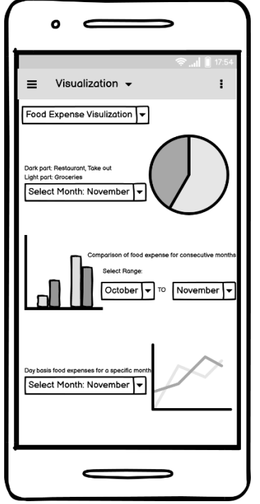

Figure 4 Visualization Prototype

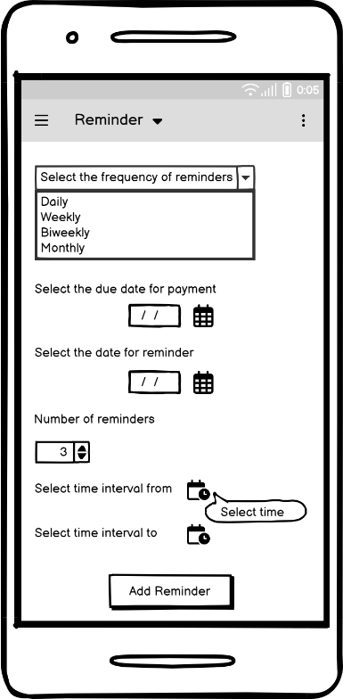

Figure 5 Reminder Prototype

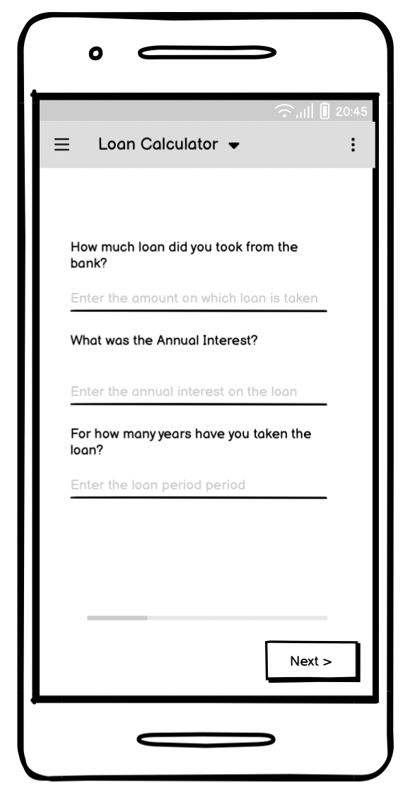

Figure 6 Loan Calculator

**Modified prototype:**

**Analyzing the data of expenditure using graphs**

In Fig 7, updated the title of the category selection in the drop-down menu to ‘Click to select category’ and Added the ‘Show Visualization’ button.

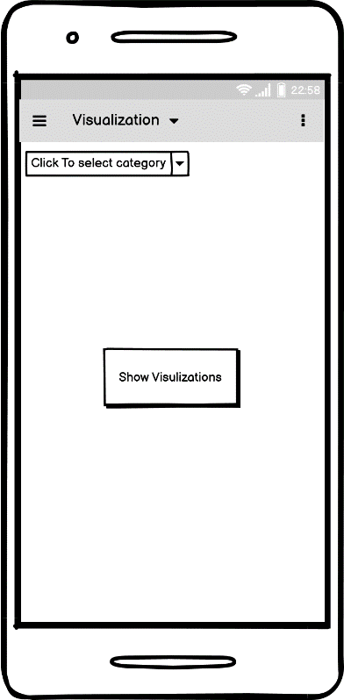

Figure 7 Updated Visualization Prototype

In fig 7, added the heading for the selected category of expenditure. Added the label ‘click dropdown to change month’. Added ‘Previous’ and ‘Home’ buttons.

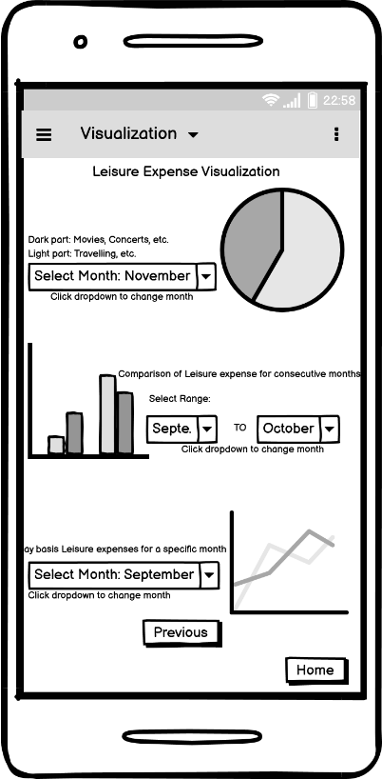

Figure 8 Updated Visualization Prototype 2[6]

**Reminders**:

The user was confused with the “Select the date for the reminder” option and did not know that the date is the start date for setting the reminder. So, we removed the “Select the date for the reminder” option and left the “select time interval” options as it is for start and end dates

**Visualization**:

Users believed that the expense category screen doesn’t have any back or next buttons. So, we added “next” and “previous” buttons for navigation. The users did not know how to change the month as there are no instructions provided for doing the task. We added an instruction on top of the box saying” Click on the box to change the month”. The user will not know how to change the category as there are no instructions provided for doing the task. So, we added an instruction on top of the box saying ‘Click the button to change/select the category. The users were not able to interpret the response as the screen does not show any action response button or description. So, we added a button “Show Visualization” rather than directly showing the data of charts

**Loan Calculator:**

In the loan calculator, confirmation of monthly installment was a redundant step, so we removed the confirmation page and merge it to the next page

**Evaluation Process – Cognitive Walkthrough**

The contextual inquiry process was done at the Goldberg Computer Science building. Users were asked to do a variety of tasks using ‘The YNAB’ app on the phone to understand their spending, saving, bill tracking activities. Pilot testing was done with two rounds of interviews and final testing with three rounds of interviews. There were three users and two researchers. Provided them with tasks and questions which were used to find out their experiences of using the application. The study lasted for about forty minutes. This approach was suitable, as we were able to find how the users were able to perform the tasks of setting reminders, analyzing expenditures and loan estimations etc. This helped us to develop an application that was intuitive, easy to navigate, and understandable for the users to take action. After doing low-fidelity prototypes, we examined Abby's motives and attitudes, as well as how she works with information and how she learns information. Based on the data, our team analyzed how Abby might have used the app, as well as the problems she would have faced when using the app to track expenses. We received some input based on the cognitive walkthrough. Our team made the necessary changes in the prototype. We also focused on how Abby would notice the new changes. We analyzed the changes we made to the low-fidelity prototype to check if it was easy for the user or not. While doing the cognitive walkthrough, the evaluators came in two rounds and performed the tasks like setting a reminder for custom time intervals, analyzing the data of expenditure using graphs, and predicting early loan payoff for interest saving. For performing these tasks, we provided users cognitive walkthrough sheet to fill up the questions. We mailed the sheets to them. The cognitive walkthrough sheet includes prototype images so the evaluators can analyze and do an evaluation for the prototype. The whole process includes the use of Microsoft Teams, Microsoft Word, and Balsamic.

**Results and Discussion**

For all three tasks, we got very informative feedback that helped us greatly to improve the user interface and thereby the user experience. We created the cost-importance table to analyze the problems the users had and to get the information required to upgrade the application. Currently, the customized frequency of setting reminders with an interval was not supported. So, we decided to add Customized interval frequency for reminders to remind users multiple times to perform a specific transaction (Bill payment, loan payment, etc.) With the use of improved reminders, users will be notified more frequently according to their pace, which will result in fewer chances of missing a payment or a transaction. The reminder feature will help users to get notified more frequently according to their pace, which will result in fewer chances of a missing payment or a transaction. Also, only two types of graphs were available, which provides limited insights for analysis. Users suggested adding more graphs should be presented for analysis. By adding more graphs users can get to know more about their expenses and savings. With the use of graphs like pie charts, line charts, bar graphs, histograms, etc., the user will get more insights into their spending habits. The visualization feature will help users to get a more in-depth analysis of their expenditure habits through various visualization like graphs such as bar graphs, pie charts, line graphs, etc. The loan calculator feature was found to be a bit complex due to the many options. Users suggested that the inputs should be easier to understand as the user should not have to spend more time understanding which detail they need to provide to the application. So, we decided that the loan calculator will ask for the previous details such as interest rate, amount of monthly installment, amount of loan, and several loan periods. At the next step, users will be asked how much amount they want to pay now per month. Using these details, the application will provide how early can the user finish installments and how much money he would save on the loan. The loan calculator feature will help the user to know how much he could save on interest if they modify installments amount by increasing or decreasing installment amounts. Users believed that the expense category screen doesn’t have any back or next buttons. So, we added “next” and “previous” buttons for navigation. The users did not know how to change the month as there are no instructions provided for doing the task. We added an instruction on top of the box saying” Click on the box to change the month”. The user will not know how to change the category as there are no instructions provided for doing the task. So, we added an instruction on top of the box saying ‘Click the button to change/select the category. The users were not able to interpret the response as the screen does not show any action response button or description. So, we added a button “Show Visualization” rather than directly showing the data of charts.

The labeling must be done properly so that the end user knows what action they need to perform to complete the task. When the information is represented graphically or through pictures, it becomes easier for the end user to understand, rather than mere text information. Applications should have a clear and consistent layout. Need to focus on the user needs and design the application, in such a way that users can understand and find it easy to navigate and use the application. Should only provide the information that is necessary to the end-user and not burden them by providing more information, which can confuse them. The application must be functional and need not be fanciful. Should follow the UI design patterns like getting feedback from the team and end users, using standard user interface controls, elements, etc.

**CONCLUSION**

With inflation rising as time passes, management of finances has been a challenge for almost everyone. To fulfill dreams and enrich lifestyle, one must have powerful money management skills and future goals set to accomplish dreams and survive inflation and maintain a healthy lifestyle.

In this work, we presented a design process of a smartphone application for Banking: spending/saving/bill tracking. To meet the user’s expectations and improve the usability of the final design we conducted two studies. The first study was focusing on the usability of current applications available in the market (YNAB- You need a budget) and learning design challenges with it. From the contextual inquiry, we observed that users are finding the UI of some parts a bit challenging due to icon sizing and lack of instructions/guide, and the fact that it required multiple clickstreams to finish one task. With respect to the analysis and conclusions of contextual inquiry, an affinity diagram was created. Through this we were able to organize recommendations and issues, also we were able to identify potential themes with tasks and features for our next study milestone. Three features Reminders, Visualizations, and a loan calculator were selected among the identified features to create prototypes and embark on to the next study phase.

We created wireframe prototypes of selected features using Balsamiq wireframes considering all the observations and responses from previous study results. We ran cognitive walkthroughs on the created prototypes with respect to the persona of Abby. We had two teams of evaluators conducting cognitive walkthroughs with provided predefined steps, and task scenarios with use cases in cognitive walkthrough sheets and were asked to note down their observations and design implications with severity affecting the usability of prototypes. After collecting responses and observations from evaluators, we fixed and updated prototypes with the following changes. We updated the title of the category selection menu, as well as added a show visualization button, a heading to show the currently selected category, a description of the month selection dropdown, and home and previous buttons to ease navigation in the application.

**Future Work**

The low-fidelity prototypes used in the study may not be able to represent all the user interface features such as colors, and animations, and should be replaced by creating high-fidelity prototypes in the future to get more in-depth observations and feedback on the usability of the design. Before creating high-fidelity prototypes, a cognitive walkthrough should be performed on updated low-fidelity prototypes to ensure the design changes are aligned with the usability of the application. More numbers of evaluators should evaluate the high-fidelity prototype design to get extensive feedback and get Heuristics Evaluation. There could be more features added into consideration such as creating groups to share expenses.

**References**

[1] Sumit Pandey. 2013. Responsive design for transaction banking - a responsible approach. In Proceedings of the 11th Asia Pacific Conference on Computer Human Interaction (APCHI '13). Association for Computing Machinery, New York, NY, USA, 291–295. <https://doi.org/10.1145/2525194.2525271>

[2] Udayan Tandon, Lavanya Siri, Apurv Mehra, and Jacki O'Neill. 2019. Designing a financial management smartphone app for users with mixed literacies. In Proceedings of the Tenth International Conference on Information and Communication Technologies and Development (ICTD '19). Association for Computing Machinery, New York, NY, USA, Article 35, 1–5. <https://doi.org/10.1145/3287098.3287131>

[3] Samia Ibtasam, Hamid Mehmood, Lubna Razaq, Jennifer Webster, Sarah Yu, and Richard Anderson. 2017. An Exploration of Smartphone Based Mobile Money Applications in Pakistan. In Proceedings of the Ninth International Conference on Information and Communication Technologies and Development (ICTD '17). Association for Computing Machinery, New York, NY, USA, Article 1, 1–11. <https://doi.org/10.1145/3136560.3136571>

[4] Makayla Lewis and Mark Perry. 2019. Follow the Money: Managing Personal Finance Digitally. In Proceedings of the 2019 CHI Conference on Human Factors in Computing Systems (CHI '19). Association for Computing Machinery, New York, NY, USA, Paper 390, 1–14. <https://doi.org/10.1145/3290605.3300620>

[5] Kathleen Sindell. 2003. Personal finance. Encyclopedia of Computer Science. John Wiley and Sons Ltd., GBR, 1397– 1400.

[6] Balsamiq. Rapid, effective and fun wireframing software. Balsamiq.com. Retrieved December 1, 2022 from <https://balsamiq.com/>

[7] What is an Affinity Diagram? K-J Method. Asq.org. Retrieved December 9, 2022 from <https://asq.org/quality-resources/affinity>

[8] 2021. YNAB. Personal budgeting software for windows, mac, iOS and android. You Need A Budget. Retrieved December 9, 2022 from https://www.youneedabudget.com/

**PLAGIARISM STATEMENT - PERSONAL DECLARATION**

"This paper constitutes original work by done by ME and my group (names and student numbers filled in below). The paper consists entirely of ideas, observations, information, and conclusions composed by the group, except for statements contained within quotation marks and attributed to the best of the group’s knowledge to their proper source in footnotes or references. Direct quotations make up a very small proportion of the text and are appropriately cited. Material paraphrased from a source (e.g., print sources, multimedia sources, web-based sources, course notes or personal interviews) has been clearly identified by a numerical reference citation (ACM or IEEE). All of the sources consulted and/or included in the report have been listed in the Reference section of the paper. All drawings, diagrams, photos, maps or other visual items derived from other sources have been identified by numerical reference citations in the caption. No part of the document has been submitted for any other course."

Names and Student Numbers of the group:

Dharmay Sureja - B00904061

Sagarkumar Vaghasia - B00878629

Radhey Rupapara - B00910695

Jayshree Ramasubramanian - B00894948

Tejaswini Rallapalli - B00888478

Date: December 8, 2022

**(Please note, filling in your name, BannerID and Date, it means that you have read and agree that the above statement is true).**